Admin: Date received: Outcome:

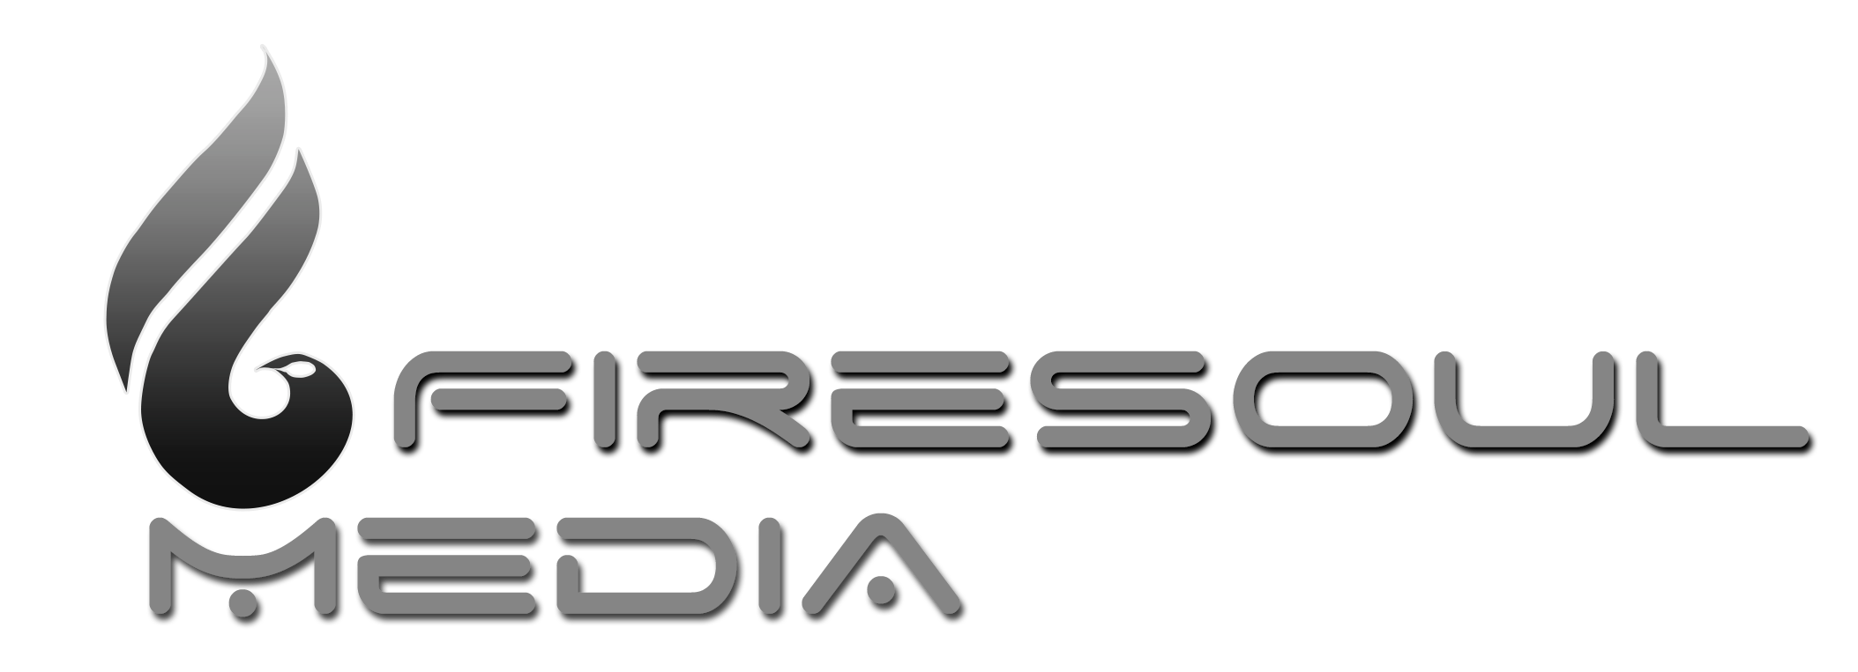
Application Form: “Tell Me A Story” Documentary Film Summer School Cuba

Personal Details
First Name
Last Name
E-Mail Address
Alternative Email
Mobile (Please include country and area code)
Home Phone (Please include country and area code)
Skype Profile
Facebook Profile (Optional)
Website (If Applicable)
Nationality *
* (NB: Please note that if you are a U.S. citizen you must apply for a visa in good time from the State Department; for information visit http://travel.state.gov/content/passports/english/country/cuba.html)
Street Address
City
Country
Post or Zip Code
Gender
Date of Birth
Current Profession

Motivation Statement

What are your reasons for applying to do this course? (500 words max)

Experience & Qualifications

Tell us about any relevant studies and or qualifications...

Tell us about any previous experience of filming and/or making a documentary...

Please provide links to any online portfolios or websites you may have...

What is your level of Spanish?

None
Basic
Intermediate
Advanced
Fluent

Native

Other Information

Please list any equipment and/or software you would be likely to bring with you on the course (Camera, Laptop, Editing Software etc) ...

If you are applying for external funding to join the course, please let us know the institution and stage of application...

Please let us know about any medical conditions, allergies or dietary requirements you may have...

Any other information relevant to your application?

Where did you hear about the course?

Google Search
Word of Mouth
Facebook
Press
Eventbrite
Other Please specify :

Person to Notify in Case of Emergency
Name
Relationship to you
Full Address
Home Phone (inc. country and area code)
Work Phone (inc. country and area code)
E-Mail Address
Alternative E-Mail
Best contact method

Equal Opportunities

We aim to provide equal opportunities without regard to race, color, religion, national origin, gender, sexual preference, age, or disability.

Agreement & Signature

By submitting this application, I affirm that the facts set forth in it are true and complete.
Name (printed)
Signature
Date

Next Steps

Please print, sign, scan and send a copy of this application form to Rebecca@firesoulmedia.com There is no fixed deadline for applications but we are accepting students on a rolling basis and look to have all places filled by mid February. Please keep a copy of this application form for your records.

IMPORTANT: Please make sure you add both info@firesoulmedia.com and Rebecca@firesoulmedia.com to your contacts list to make sure all further communications reach your inbox. We aim to respond to all applications with a decision within 14 days. If you have not heard from us after that time, please send us a courtesy email to check that we have received your application.

Thank you for completing this application form and for your interest in joining us as a student at the Summer School. We look forward to hearing about your motivations for joining the course.

